**TRIGONOMETRY REVIEW (13.2, 13.3, 14.2, 14.3, 14.4)**

**SPRING FINAL EXAM - ALGEBRA II**

**NO CALCULATORS!**

**The** **measure** ***θ*** **of** **an** **angle** **in** **standard** **position** **is** **given.** **Find** **the** **exact** **values** **of** **cos** ***θ*** **,**  **sin** ***θ* and *tanθ***  **for** **each** **angle** **measure.**

**1.** 30o **2.** 45° **3. ** radians **4. $\frac{π}{6}$**  radians

**Convert** **each** **angle** **measure** **into** **its** **equivalent** **in** **radians** **or** **degrees.**

**5.** 315° **6. ** radians **7. ** radians **8.** 400o

**9. ** radians **10.** 270o  **11. ** radians **12.** 135o

**In which quadrant does the terminal side of each angle lie?**

**13.** 145o **14.** -102o **15.** 400o **16.** -195o

**Find the measure of an angle between 0o and 360o coterminal with each angle.**

**17.** -102 **18.** 433**o 19.** -214o **20.** -60o

**Find the exact value of each.**

**21.** sec 45o **22.** csc 60o **23.** cot30o **24.** sec 60o

**Suppose cos** ***θ* = $\frac{5}{13}$, find the exact value of each, as a fraction.**

**25. sin** ***θ* 26. csc** ***θ* 27. sec** ***θ* 28. cot** ***θ***

**Given the diagram below, find the exact value of all 6 trig functions, written as a simplified fraction.**

**Y**

**10 29. sin** ***Y* 30. cos** ***Y* 31.tan** ***Y***

**32. csc** ***Y*  33. sec** ***Y* 34. cot** ***Y***

**A 8 E**

**CALCULATORS ARE PERMITTED FOR THESE PROBLEMS.**

**35.** In triangle JOB, <O is the right angle. Two measures are given. Find the remaining sides and angles to the nearest tenth.

m< B = 20o and *j = 6*

**36. Find the area of the triangle. Round to the nearest tenth.**

52o

**5 14**

**Solve each problem. Round to the nearest tenth.**

**37.** The world’s tallest unsupported flagpole is a 282-ft-tall steel pole in Surrey, British Columbia. The shortest shadow cast by the pole during the year is 137 ft long. What is the angle of elevation of the sun when casting the flagpole’s shortest shadow?

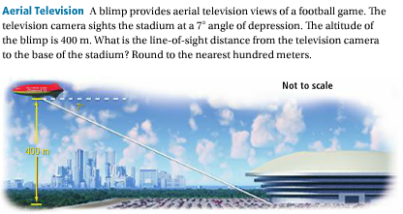

**38.**

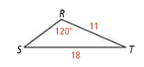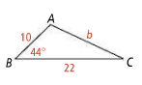**39.** Find the measure of <S. **40.** Find the measure of *b.*

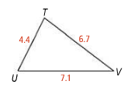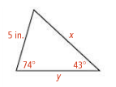**41.** Find the measure of <V. **42.** Find the measure of *x* and *y.*